**CHAPTER III  
PROBLEM ANALYSIS**

### III.1 Requirements to Using Barcode Scanner

Implementing linear barcode in this paper using Android smartphone device and the software “Barcode Reader” to scanning the linear barcode. The authors choose android as device to scan the barcode because android To implementing linear barcode, not need high specification of Android smartphone but its need minimum requirement:

1. Android Smartphone with camera must be clearly picturing when scanning linear barcode (not blur).
2. The software to scanning linear barcode, in this paper using software that name Barcode Reader and it can be download and get in play store.

The Recommended Requirement to implementing :

1. Android Smartphone with camera 13MP with resolution 4160 x 3120 pixel that have auto-focus, LED Flash, Touch Focus
2. The Barcode Scanner that have a high rank in the play store or that have a web search to search the information product of linear barcode.

### III.2 Implementation of Application Barcode Reader on Barcode Scanner

first, to read linear barcodes using a barcode scanner app on android, we have to download it in Playstore.. After installing the software of Barcode Reader to user device, now user can use it to scan the linear barcode using user Android Smartphone device and the software of Barcode Reader that already installed. There are many step to scan barcode, are as follow:

1. Open the barcode scanner application.
2. Point the camera into the linear barcode.
3. Scan the linear barcode using user Android Device.

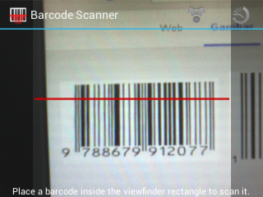

**Figure 3.1 Software Linear Barcode Reader**

1. When the linear barcode already scanned, it will give a result.

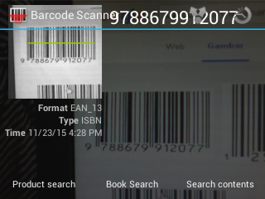

**Figure 3.2 Software Linear Barcode Reader**

1. Then user can check the character of the result scanning the linear barcode in the last by click Web Search.

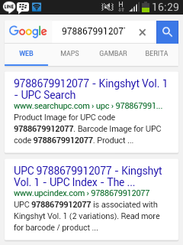

**Figure 3.3 Software Linear Barcode Reader**

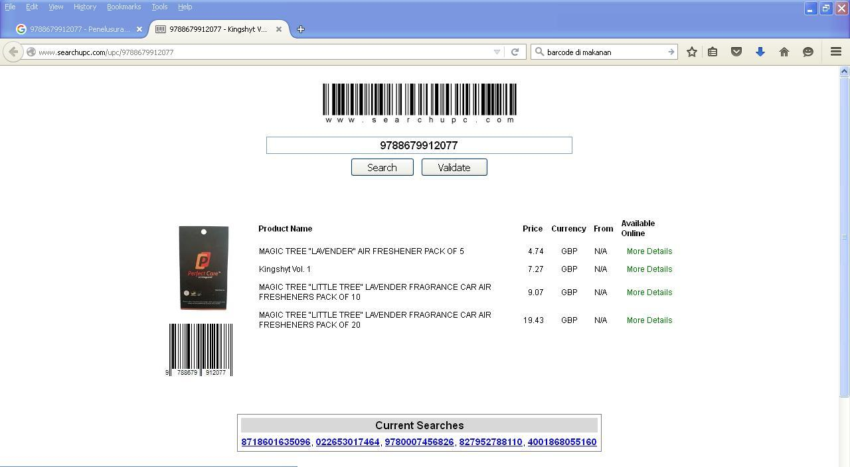

**Figure 3.4 Software Linear Barcode Reader**

1. Then, the information of linear barcode that scanned in the last, it will be display what the product / information have in the linear barcode.

### III.3 Advantages and Disadvantage of Barcode Scanner

### The barcode scanner has advantages and disadvantages in its use, among others, as follows :

### Advantage :

1. The people could know the details of the barcode that we scan to look for the code on the Internet.
2. Easier to use than a regular barcode scanner, simply by downloading the barcode reader application.
3. Can be use wherever user are, because it’s portable device that no need depends on anything else (except the camera).
4. Can be used with everyone’s.
5. Very Low-Price.

Disadvantage :

1. During dark conditions, the barcode will be hard and can be impossible to scanning, because isn't use an infrared laser to processing the scanning linear barcode.
2. Requires an Internet connection to browse the details of the barcode that has been read.
3. Low accurate when the camera isn’t clearly to picture a linear barcode when process scanning (blur when scanning the linear barcode)
4. When the linear barcode isn’t thickness, it will be harder to scanning it and take for couple minutes.
5. When the position of camera when scanning linear barcode isn’t correct, it will be taken for couple minutes to read that’s linear barcode.